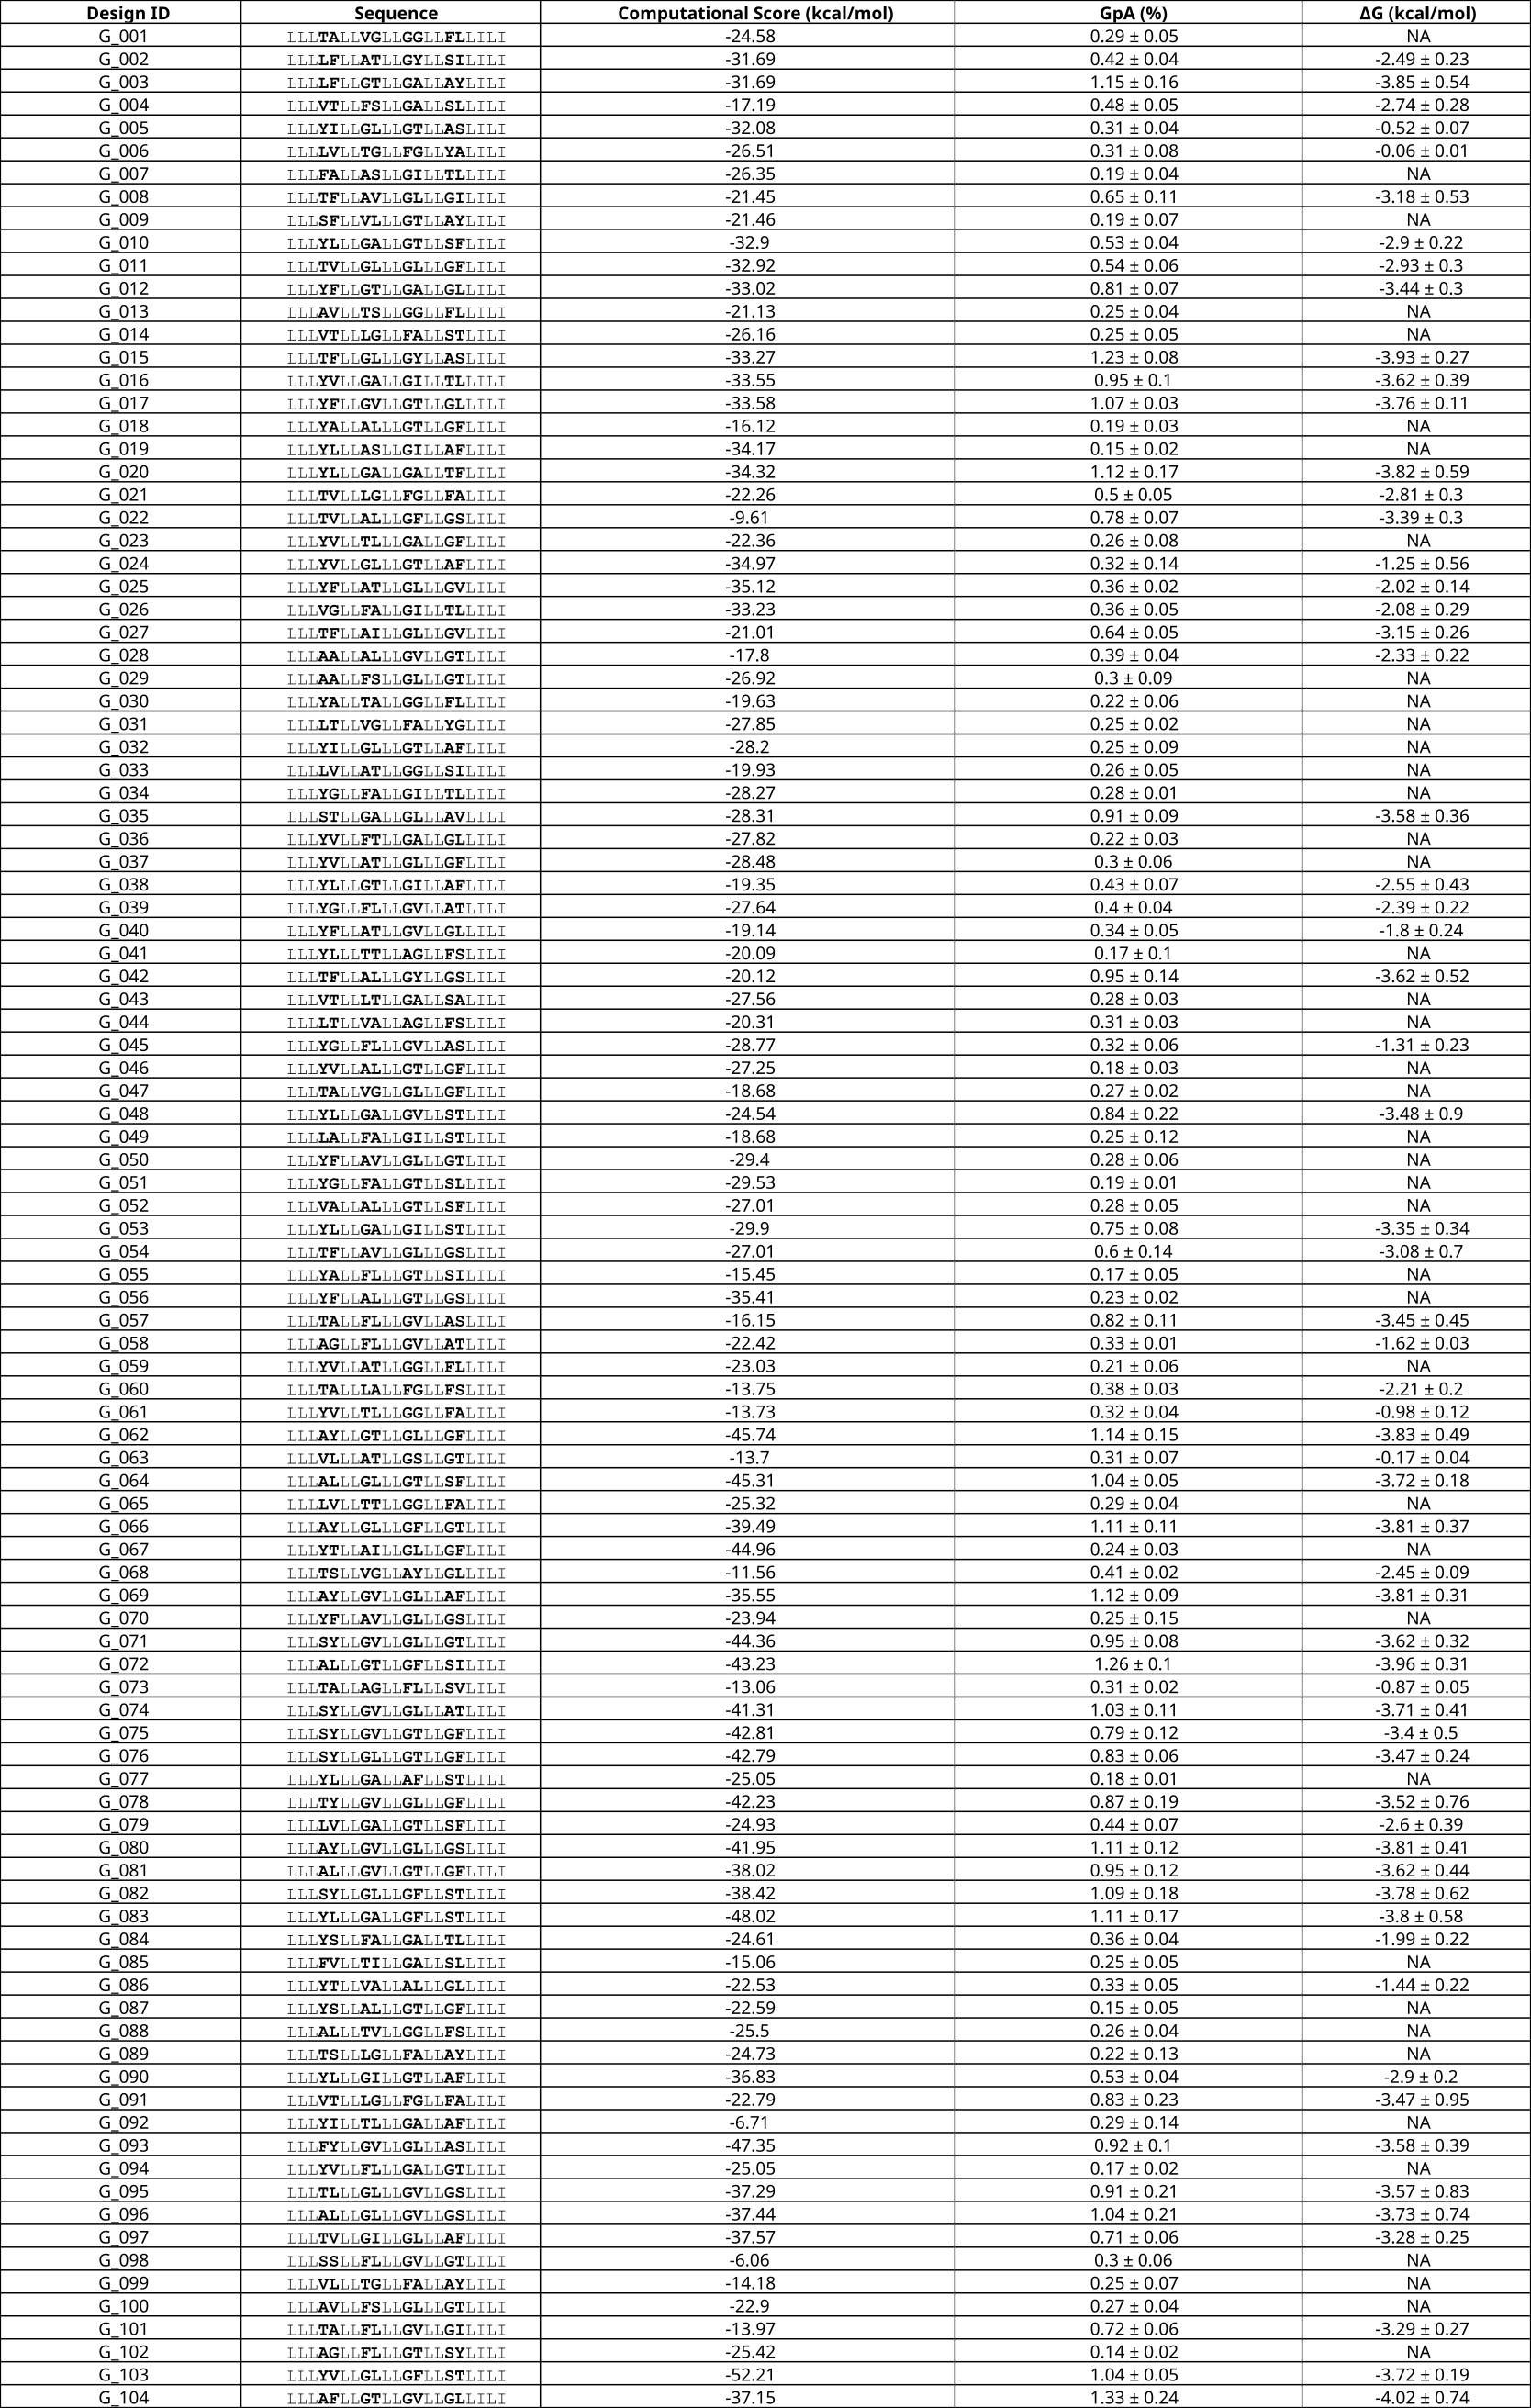**Table S1. Validated set of GASright designs**



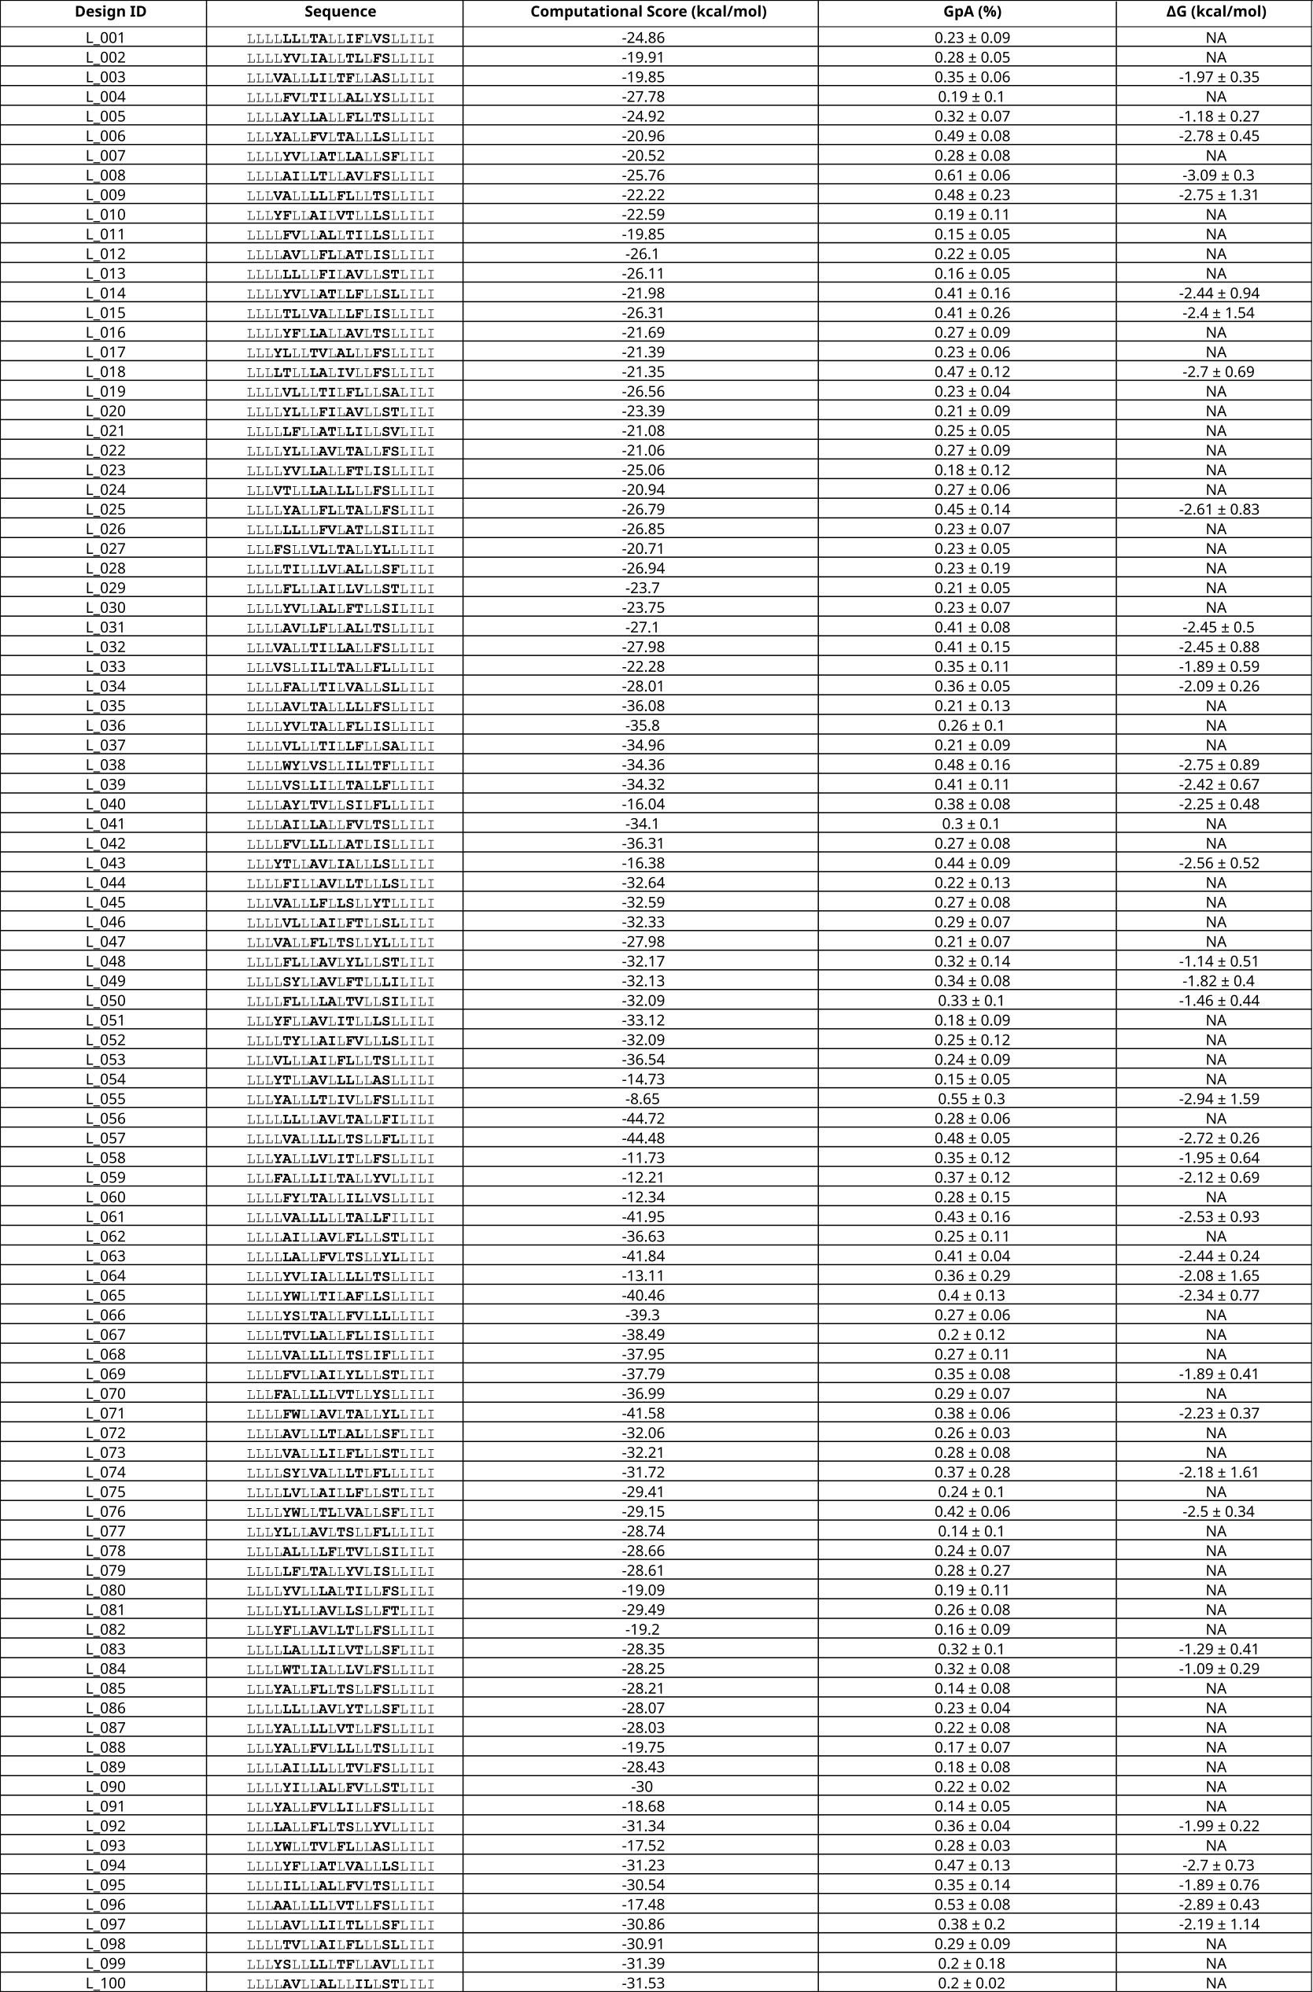**Table S2. Validated set of Left designs**



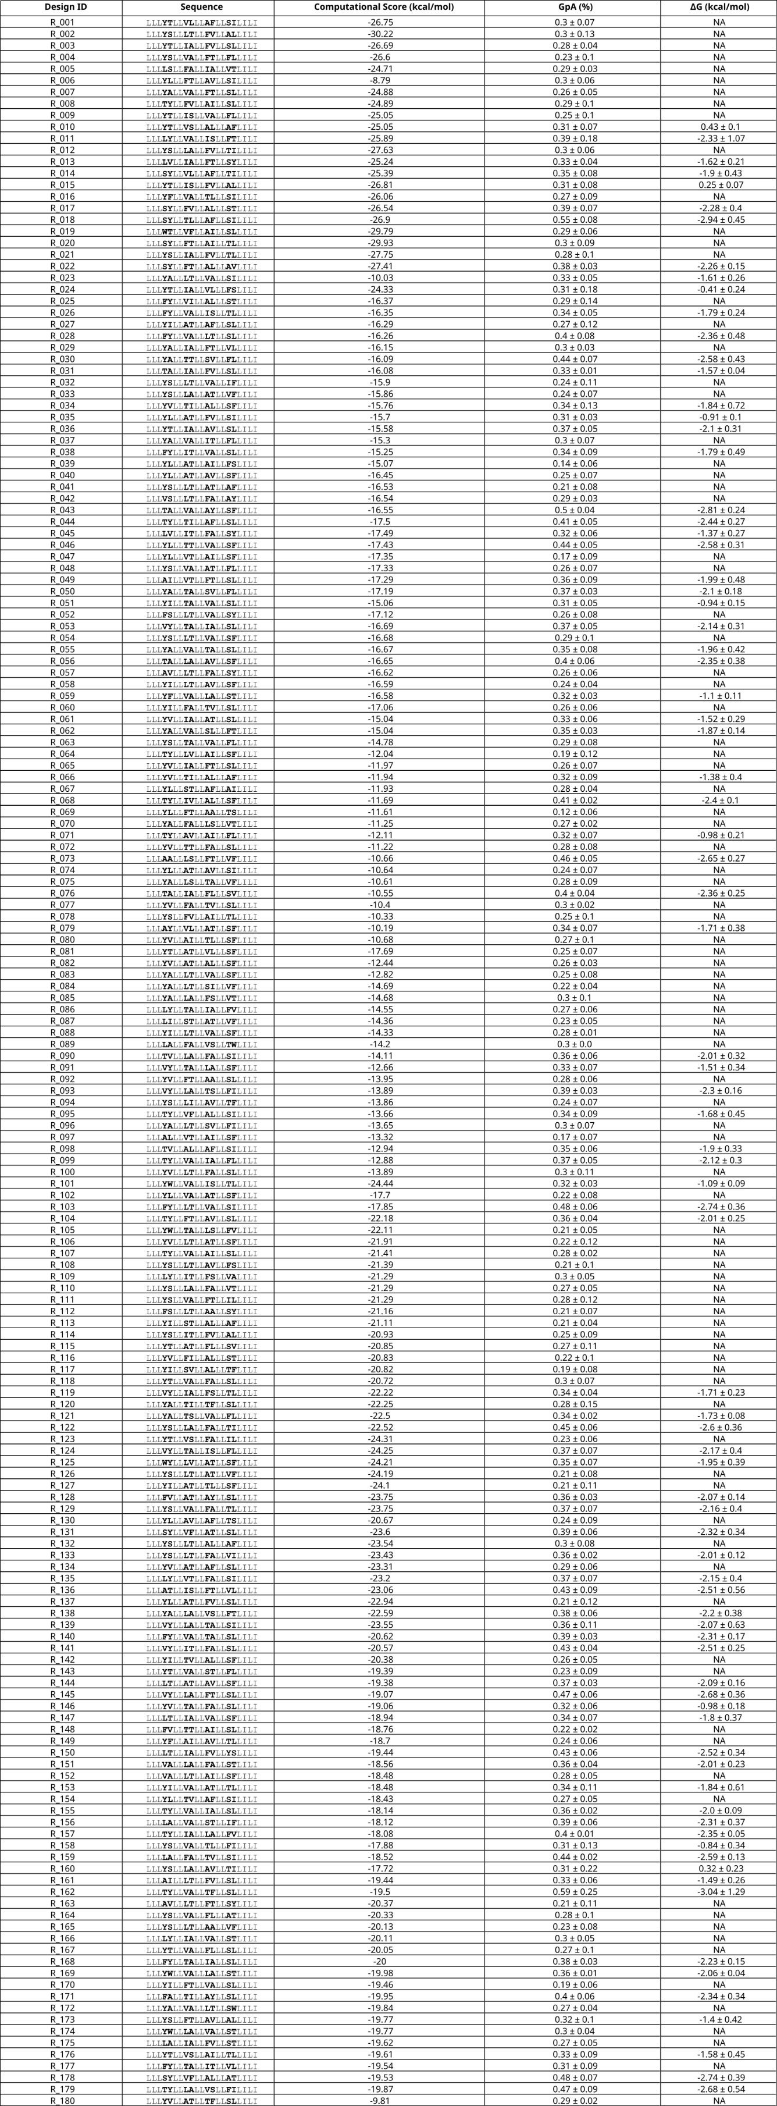**Table S3. Validated set of Right designs**



****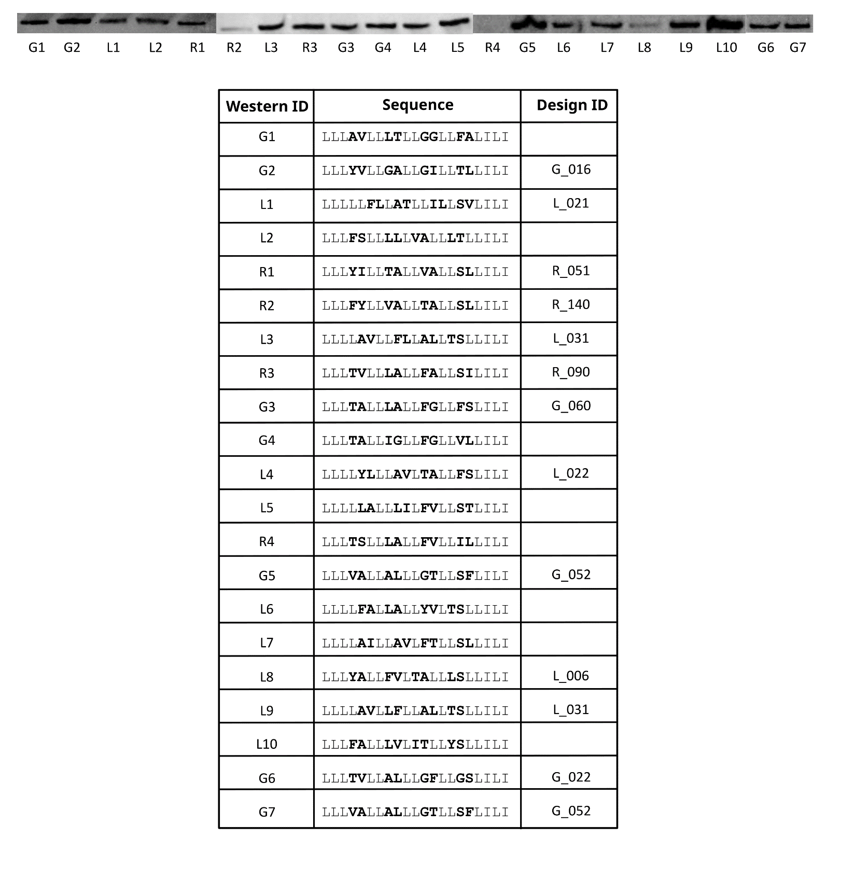

Data for validated sets of designs where clashing mutations < 35% GpA

Interfacial designed positions of each sequence in bold

Designs where a positive ΔG was calculated are designated NA

**Figure S1. Immunoblotting of designed constructs.** A subset of designed constructs were verified for their expression levels with western blots. While GASright and Left show similar levels of expression, Right designs often have fainter bands on western blots. Sequences without a Design ID are present in our sort-seq data but not part of our validated set (clashing mutants < 35% GpA)

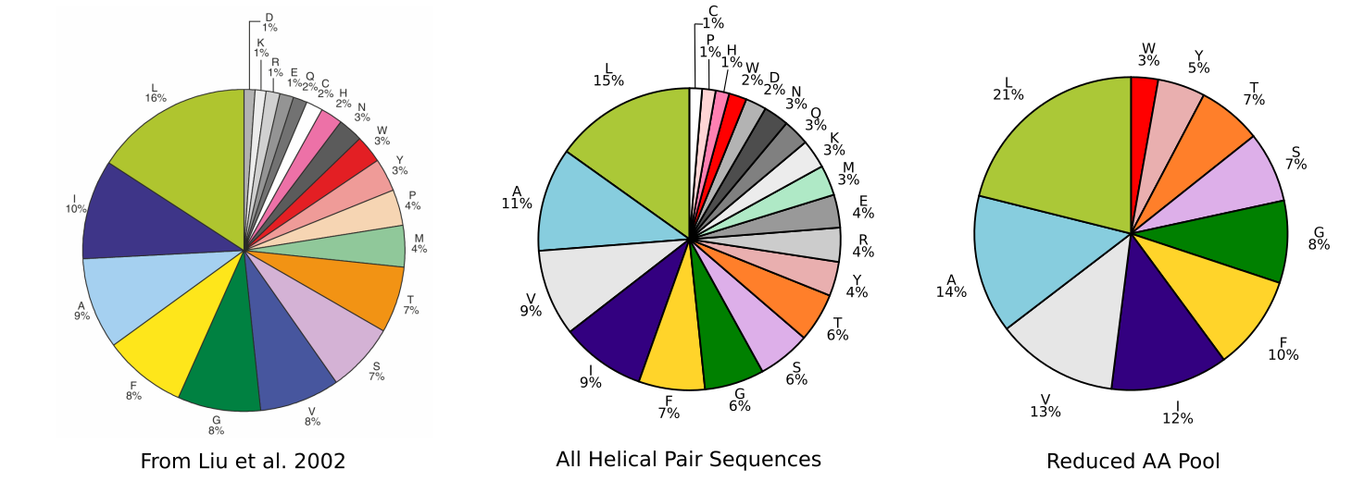

**Figure S2. Amino acid composition.** Frequency of amino acids from all transmembrane helical sequences extracted from OPM (Middle) as compared to membrane proteins from Liu et al. 2002 (Left). The frequency of the reduced pool of amino acids used for design (Right). Sequences were designed with interfaces aiming to match the frequency of the reduced pool of amino acids (SEQUENCE_ENTROPY).

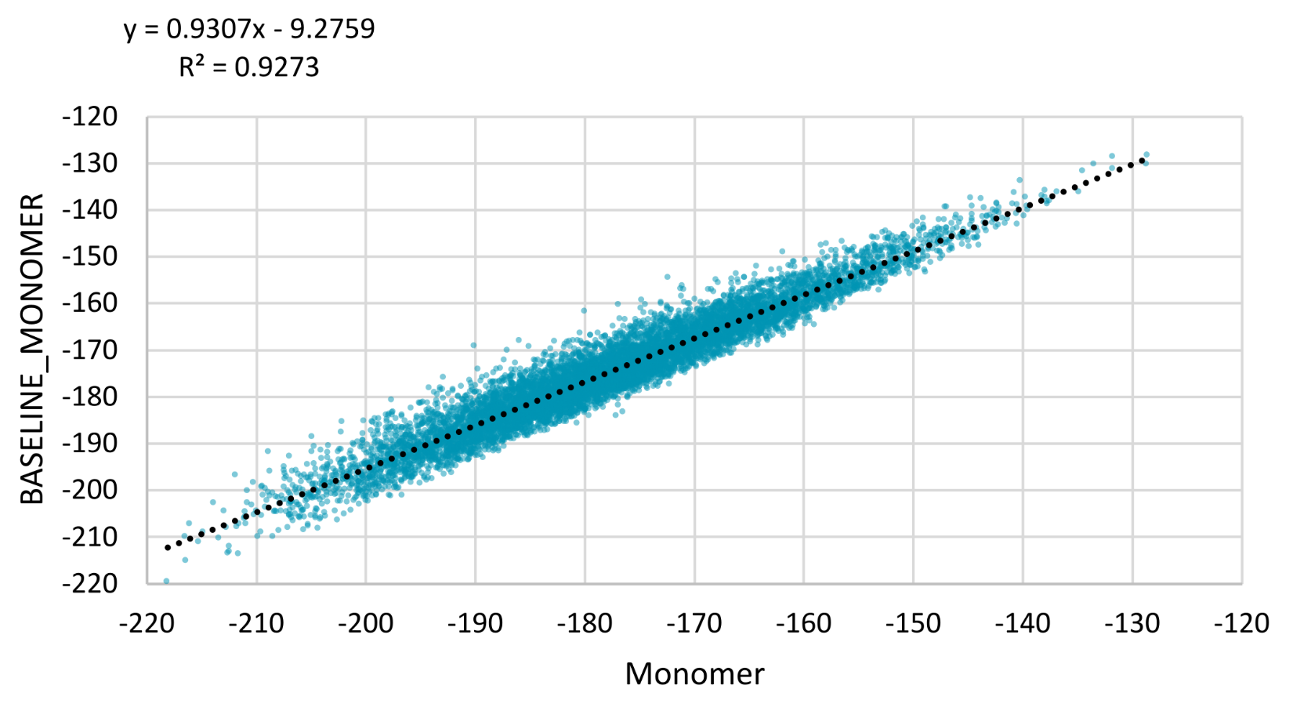

**Figure S3. BASELINE_MONOMER.** Calculated monomer energy as compared to the estimated term BASELINE_MONOMER used in the sequence design search.

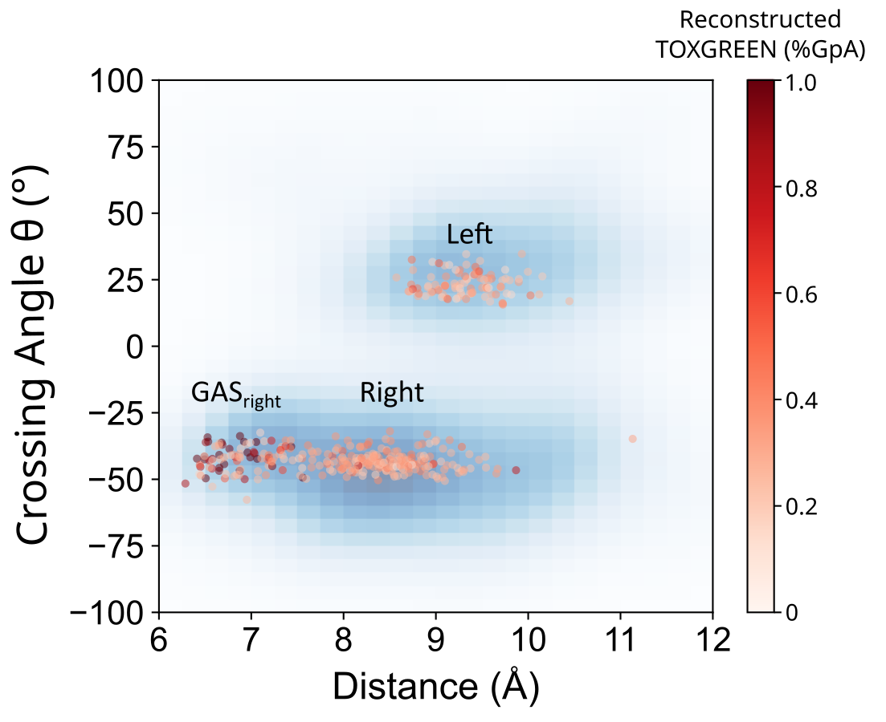

**Figure S4. Output Geometry vs Dimerization Propensity.** Distance and crossing angle of validated designed sequences plotted against %GpA in red. Sequences with highest dimerization propensity are dark red, most often found in GASright.

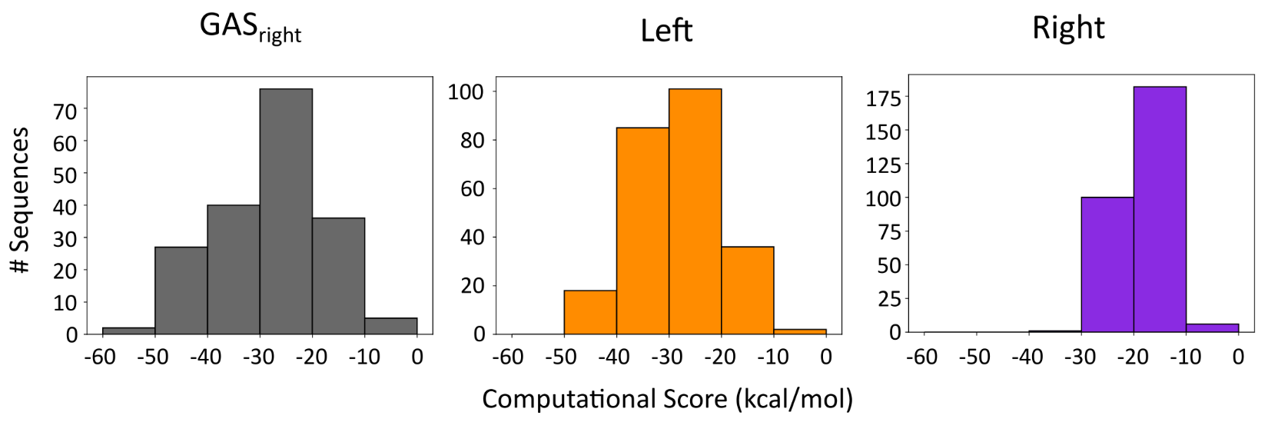

**Figure S5. Frequency of sequences by computational score.** Computationalenergy score of sequences present in sort-seq and the frequency for each design region.

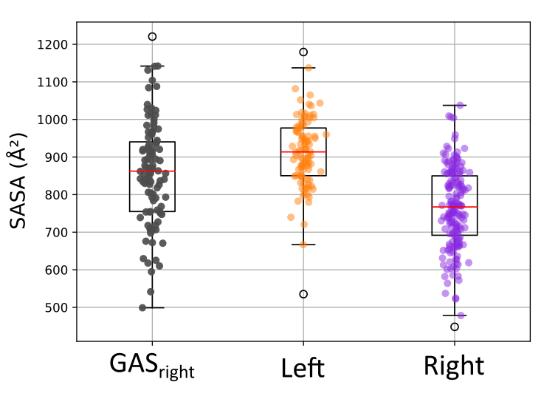

**Figure S6. Interface SASA.** Boxplots of calculated SASA at the interface of design structures of validated sequences. GASright and Left design interfaces are larger than Right, which may contribute to Right designs having a lower computational energy score.

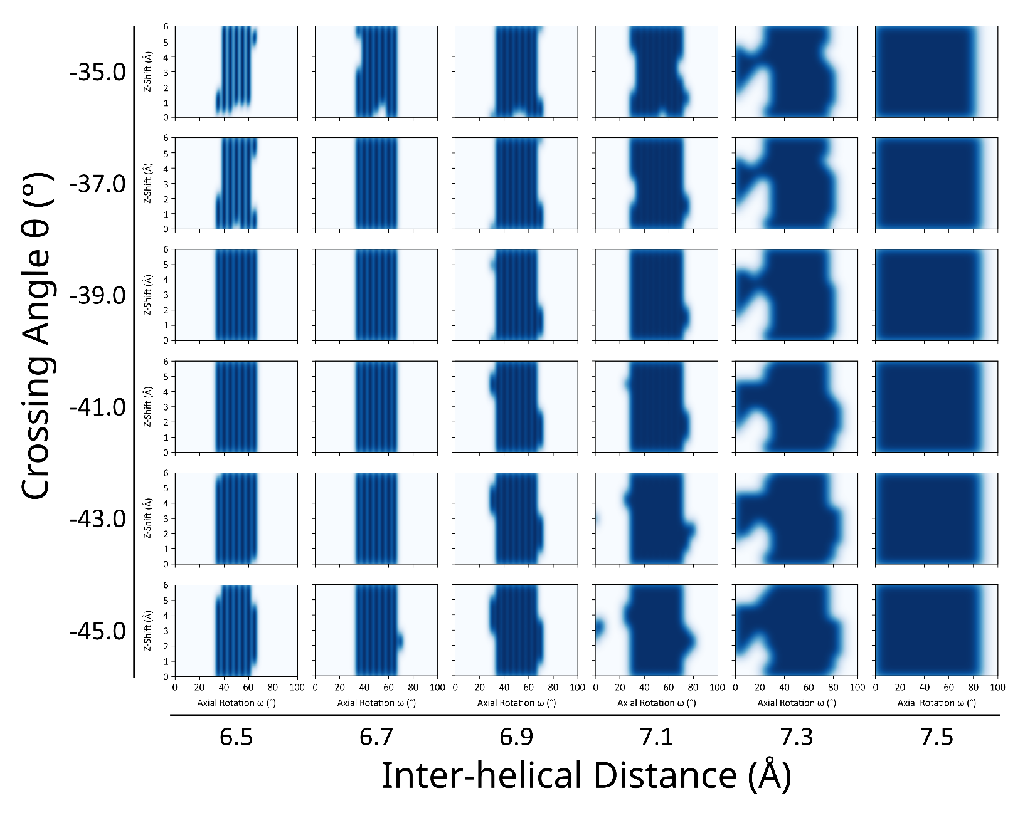

**Figure S7. GASright axial rotations and z-shifts.** A 4-dimensional grid of geometries were randomly generated to determine axial rotations and z-shifts for design. Poly-leucine helices with Ala at the design interface positions were placed at 3000 geometries and computational energy score measured. Geometries where energy score < 10 kcal/mol were plotted on a KDE plot of Z-Shift vs Axial Rotation. Values with KDE > 0.8 were randomly selected for design.

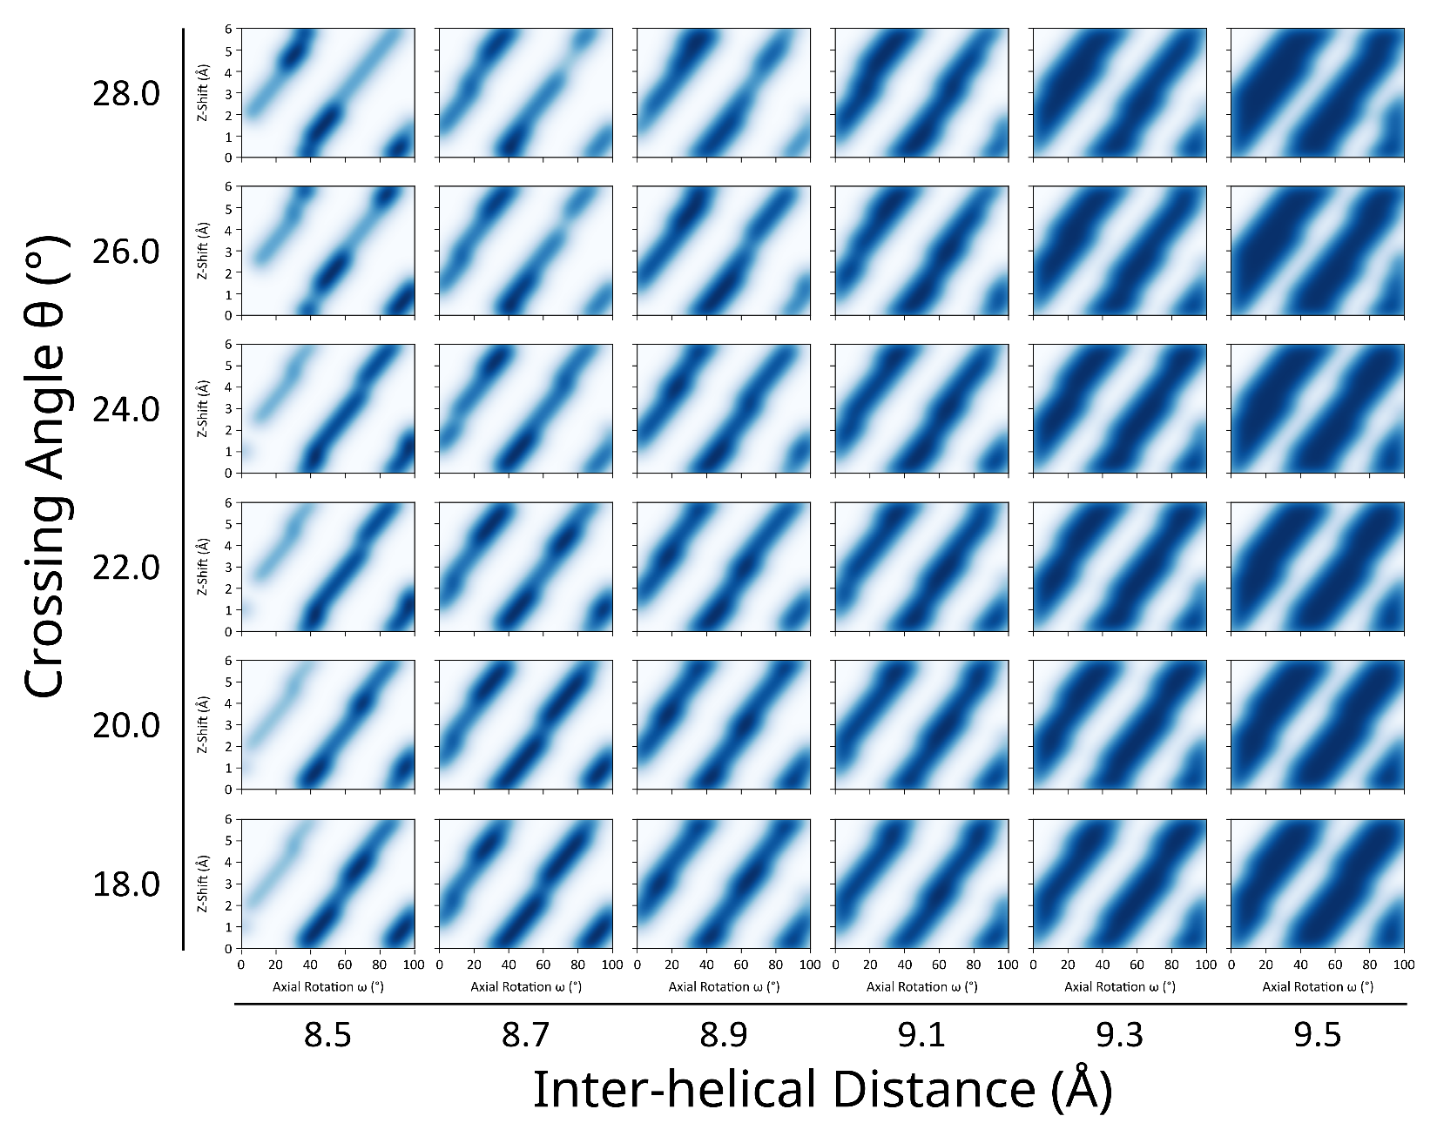

**Figure S8. Left axial rotations and z-shifts.** A 4-dimensional grid of geometries were randomly generated to determine axial rotations and z-shifts for design. Poly-leucine helices with Ala at the design interface positions were placed at 3000 geometries and computational energy score measured. Geometries where energy score < 10 kcal/mol were plotted on a KDE plot of Z-Shift vs Axial Rotation. Values with KDE > 0.8 were randomly selected for design.

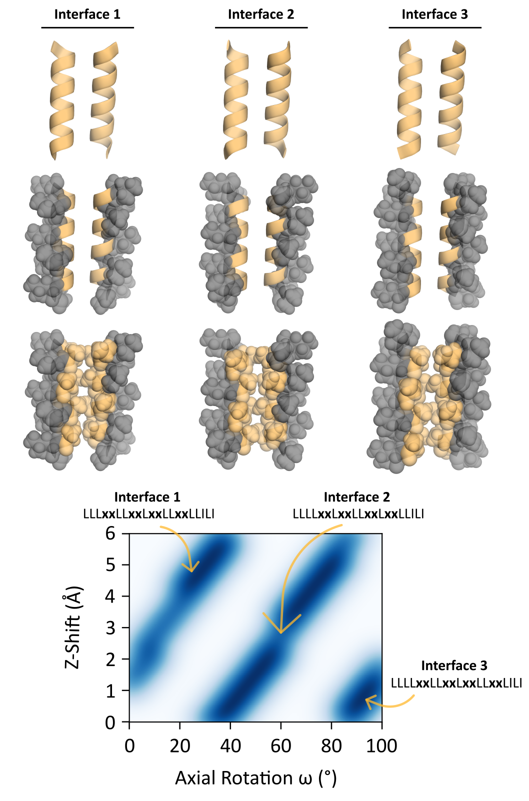

**Figure S8. Left interfaces.** Left-handed interfaces chosen based on which stripe of the axial rotation and z-shift density.

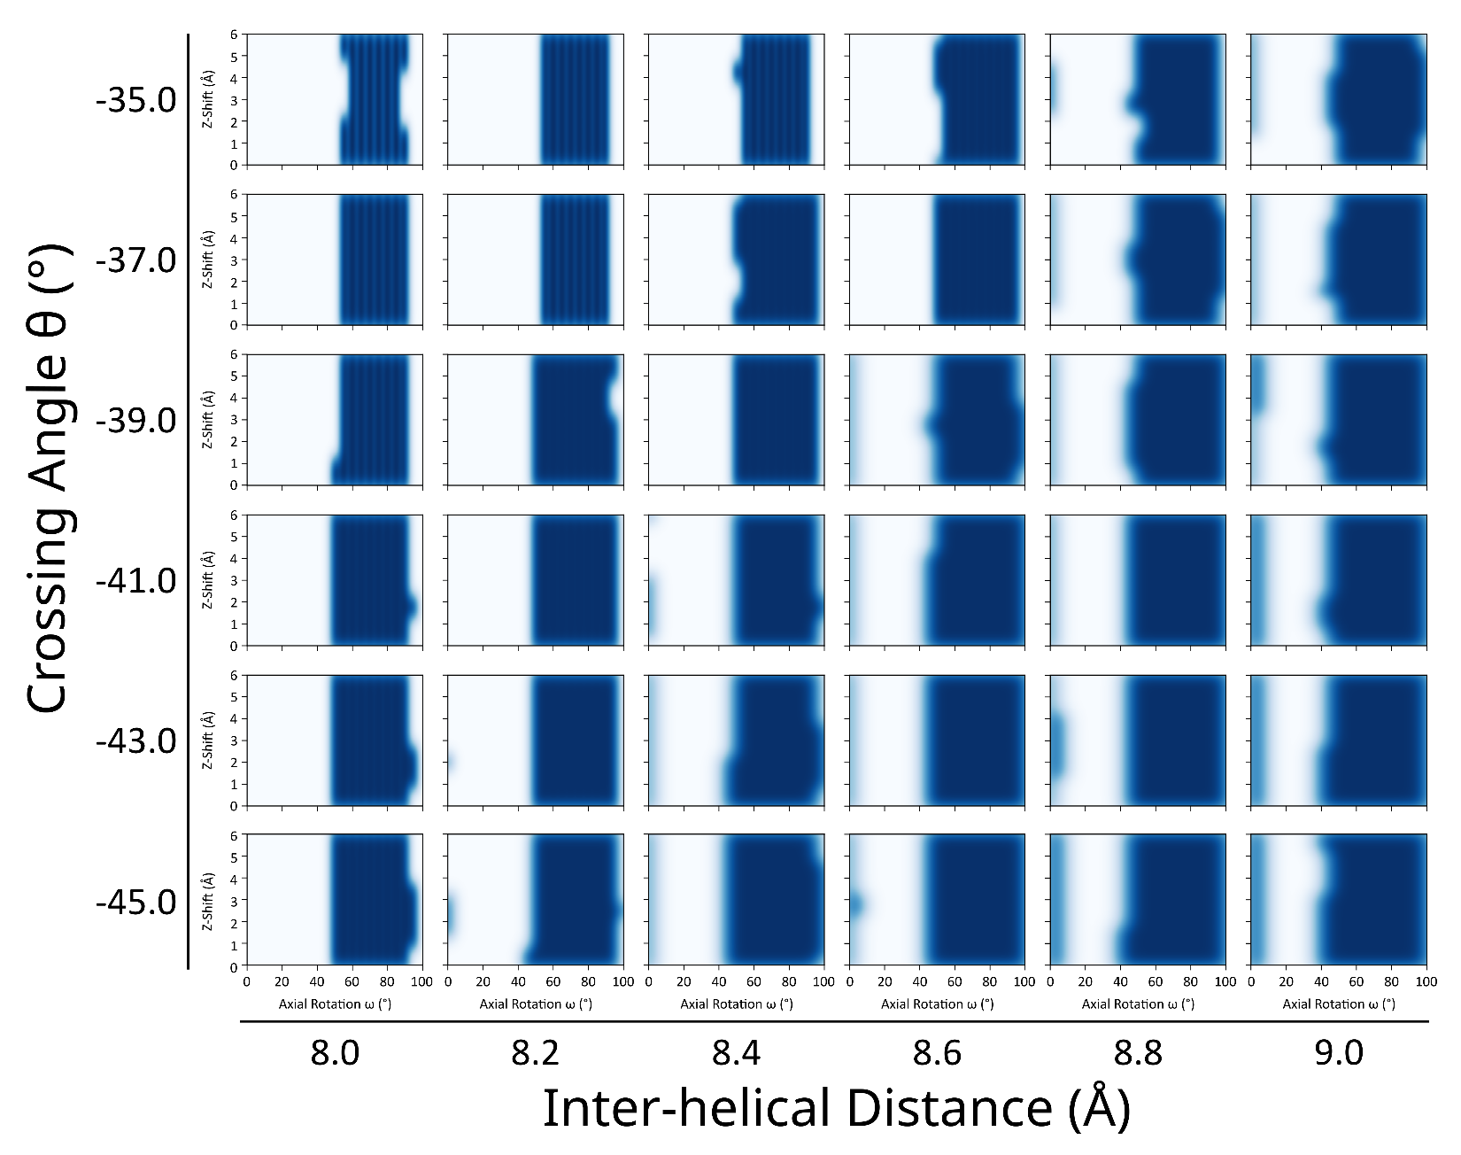

**Figure S9. Right axial rotations and z-shifts.** A 4-dimensional grid of geometries were randomly generated to determine axial rotations and z-shifts for design. Poly-leucine helices with Ala at the design interface positions were placed at 3000 geometries and computational energy score measured. Geometries where energy score < 10 kcal/mol were plotted on a KDE plot of Z-Shift vs Axial Rotation. Values with KDE > 0.8 were randomly selected for design.